オートマトンと言語　演習問題

276156 根本 貴大

問3. 入力記号の有限集合𝛴={0,1}とする．また，NFA 𝑀3=(𝑄,Σ,𝛿,𝑞0,𝐹)は次の図示表現で与えられるとする．非決定性有限オートマトンを，部分集合構成法を用いて決定性有限オートマトンに返還せよ．解答にあたっては，最終的な決定性有限オートマトンのみではなく，解答に至る過程を理解できるように記述すること．

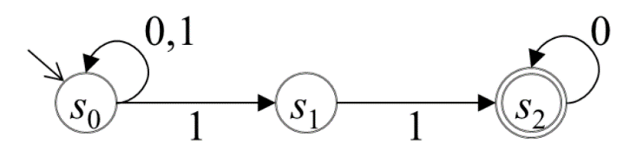

Q = {φ,{s0},{s1},{s2},{s0, s1},{s0, s2},{s1,s2,},{s0,s1,s2}}

F = {{s2},{s0,s2},{s1,s2},{s0,s1,s2}}

δ = (φ,0) = {φ}, (φ,1) = {φ}

(s0,0) = {s0}, (s0,1) = {s0}

(s1,0) = {φ}, (s1,1) = {s2}

(s2,0) = {s2}, (s2,1) = {φ}

((s0, s1),0) = {s0}, ((s0, s1),1) = {s0,s1,s2}

((s0, s2),0) = {s0,s2}, ((s0, s2) ,1) = {s0,s1}

((s1,s2,),0) = {s2}, ((s1,s2,) ,1) = {s2}

((s0,s1,s2) ,0) = {s0,s2}, ((s0,s1,s2) ,1) = {s0,s1,s2}

NFA M

|  |  |  |
| --- | --- | --- |
|  | 0 | 1 |
| →s0 | {s0} | {s0,s1} |
| s1 | {φ} | {s2} |
| *s2 | {s2} | {φ} |

0

DFA M

|  |  |  |
| --- | --- | --- |
|  | 0 | 1 |
| {φ} | {φ} | {φ} |
| →{s0} | {s0} | {s0,s1} |
| {s1} | {φ} | {s2} |
| {s2} | {s2} | {φ} |
| {s0, s1} | {s0} | {s0,s1,s2} |
| {s0, s2} | {s0,s2} | {s0,s1} |
| {s1,s2,} | {s2} | {s2} |
| {s0,s1,s2} | {s0,s2} | {s0,s1,s2} |

1

1

1

0

0

1

{s0,s2}

0